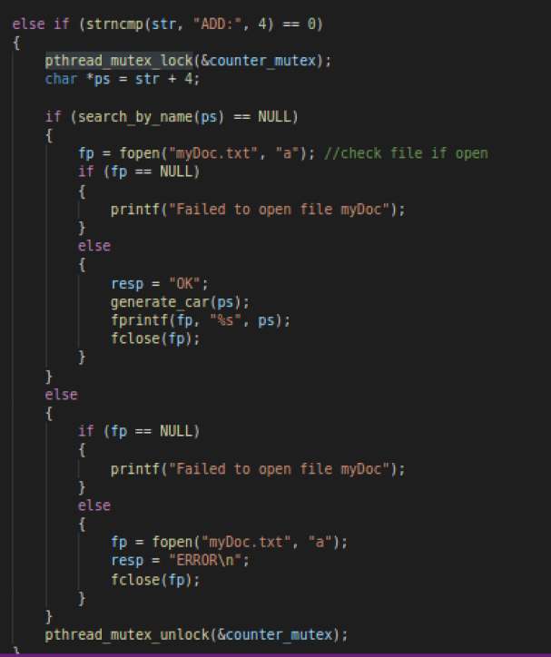

The mutex will help protect the variables and the files by accepting request from one client at a time so there won’t be any duplicated responses added in the text file and in the linked list